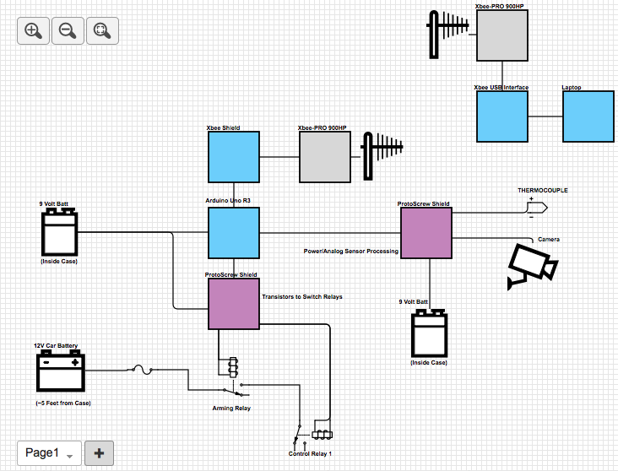**NOTES**: -Only one relay for controlling actuators (Control Relay 1) is shown. It is not known at this time how many relay channels must be supported, and further ones will have the common pin connected through the NO pin of the arming relay.

Black box Hardware Overview Diagram – Launch Relay System

-The thermocouple and camera are only examples of sensors that may be used. The driving and amplification circuits (in the “Power/Analog Sensor Processing” block) are dependent on the actual sensors needed, and will be decided in the future.